Ideation Phase
Define the Problem Statements

Date | 8 July 2026
Team ID | SWTID-2026-1342
Project Name | Nutrition Assistant
Maximum Marks | 2 Marks

Customer Problem Statement Template:
Create a problem statement to understand your customer's point of view. The Customer Problem Statement template helps you focus on what matters to create experiences people will love.
A well-articulated customer problem statement allows you and your team to find the ideal solution for the challenges your customers face. Throughout the process, you’ll also be able to empathize with your customers, which helps you better understand how they perceive your product or service.
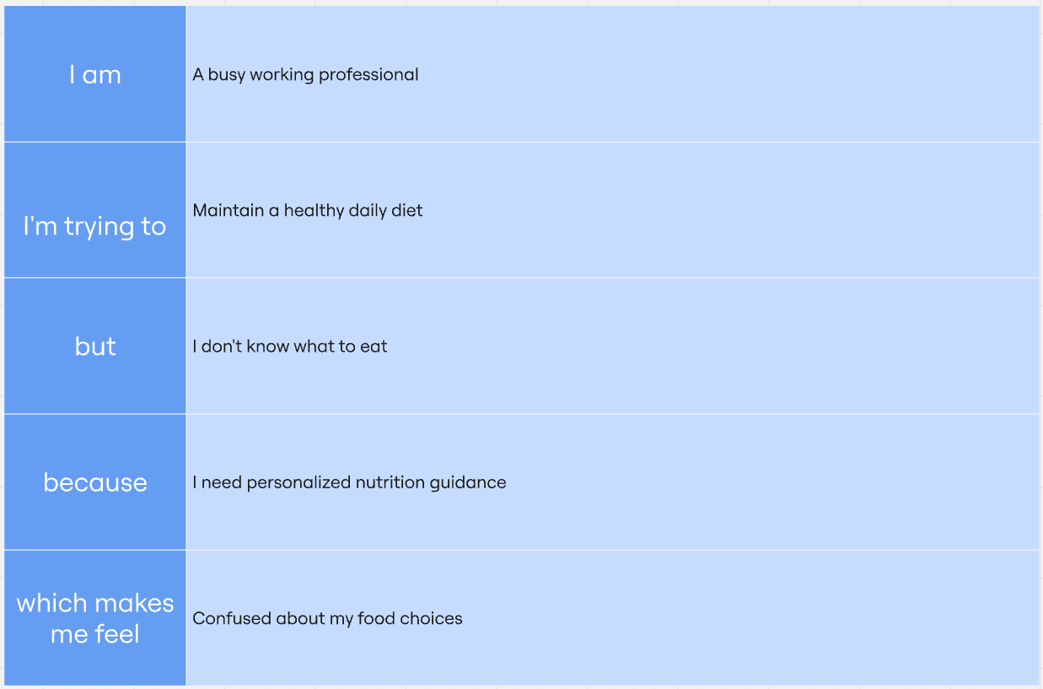

Example:
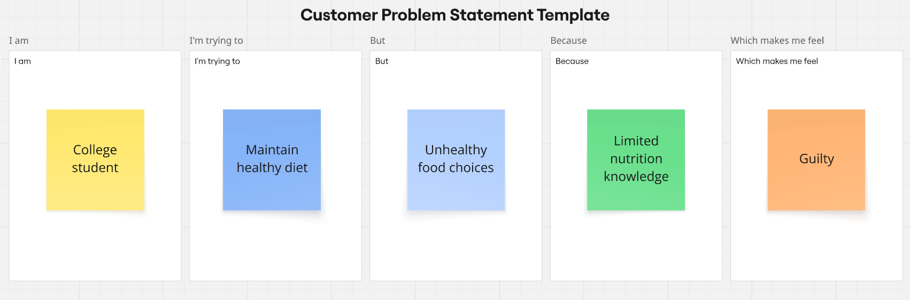
Problem Statement (PS) | I am (Customer) | I’m trying to | But | Because | Which makes me feel
PS-1 | A health-conscious individual who wants to maintain a balanced diet. | Find a personalized nutrition plan that matches my body details and fitness goals. | I don't know how many calories or nutrients I need every day. | Calculating calories and macronutrients manually is difficult and time-consuming. | Confused and unable to follow a proper nutrition plan.
PS-2 | A fitness enthusiast trying to achieve my health goals. | Plan healthy meals based on my weight, height, activity level, and goal. | Most diet plans available online are generic and not personalized. | They do not consider my individual health information and lifestyle. | Unsure about whether I am following the right nutrition plan.

